|  |  |
| --- | --- |
| **Title** | **Basic Database Operations - Online Address book** |

|  |
| --- |
| users |
| id int(40) auto_increment (primary key) |
| Username varchar(40) |
| Password varchar(40) |
| Email varchar(40) |

|  |
| --- |
| address |
| id int(40) auto_increment (primary key) |
| user_id int(40) (Foreign key) |
| Full_name varchar(50) |
| Nick_name varchar(50) |
| Phone_number varchar(50) |
| Address text |
| Website varchar(40) |
| Date_of_birth Date |

|  |  |
| --- | --- |
| **Title** **:** | **Data Validation** |

|  |
| --- |
| registration_forms |
| id int (40) auto_increment (PRIMARY KEY) |
| Name varchar(40) |
| Roll varchar(40) |
| Father_Name(40) |
| Date_of_birth Date |
| Address text |
| Email varchar(40) |
| Phone_no varchar(40) |
| Education_quality varchar(40) |

|  |  |
| --- | --- |
| **Title :** | **Online Polling System** |

|  |
| --- |
| users |
| id int(40) auto_increment(primary key) |
| Username varchar(40) |
| Roll_no varchar(40) (primary key) |

|  |
| --- |
| pollings |
| id int(40) auto_increment (primary key) |
| user_Roll_no varchar(40) (foreign key) |
| Symbol varchar(40) |
| Picnic_place(40) |
| Vote_count integer(250) |

|  |  |
| --- | --- |
| **Title** **:** | **A simple Blog** |

|  |
| --- |
| users |
| id int(40) auto_increment (primary key) |
| Password varchar(50) |
| Fullname varchar(50) |
| Country varchar(50) |
| Email varchar(50) |

|  |
| --- |
| posts |
| id int(50) auto_increment (PK) |
| user_id int(40) (foreign key) |
| Post_date Date |
| Post_category varchar(50) |
| Tag varchar(40) |
| Post_body text |

|  |
| --- |
| comments |
| id int(40) auto_increments (PRIMARY KEY) |
| post_id int(50) (foreign key) |
| user_id int(40) (foreign key) |
| Comment_body text |

|  |  |
| --- | --- |
| **Title** | **File uploading and Server side file management** |

|  |
| --- |
| users |
| id int(40) auto_increments(primary key) |
| Username varchar(40) |
| Password varchar(40) |
| Full_name varchar(40) |
| Email varchar(40) |

|  |
| --- |
| albums |
| id int(40) auto_increments (primary key) |
| user_id int(40) (foreign key) |
| photo_id int(40) (foreign key) |
| Title varchar(40) |
| Description text |
| Date date |

|  |
| --- |
| photoss |
| id int(40) auto_increments (primary key) |
| user_id int(40) (foreign key) |
| Title varchar(40) |
| Description text |
| Photo_tag varchar(40) |

|  |  |
| --- | --- |
| **Title** **:** | **B2C E-Commerce (A simple Shopping Cart)** |

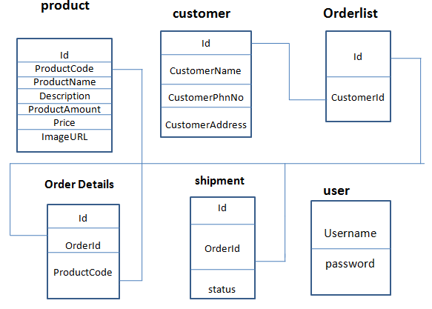

|  |  |
| --- | --- |
| **Title** **:** | **Supplier Oriented B2B - eAuction** |

|  |
| --- |
| users |
| id int(40) auto_increments (primary key) |
| FullName varchar(40) |
| Email varchar(40) |
| Password varchar(40) |

|  |
| --- |
| bid_details |
| id int(40) auto_increment(primary key) |
| user_id int(40) (foreign key) |
| product_id int(40) (foreign key) |
| latestBidingPrice float |

|  |
| --- |
| products |
| id int(40) auto_increments (primary key) |
| productName varchar(40) |
| Description text |
| photoURL varchar(40) |
| Biding_price float |
| Start_time varchar(40) |
| End_time varchar(40) |